Hypomineralized Teeth
Description
Healthy dental enamel is the hardest tissue in the human body. The enamel of hypomineralized teeth have areas with less minerals resulting in enamel that is softer and more porous. This affected enamel has a lower concentration of calcium and phosphorus and an elevated level of carbon. Appearance of these teeth can range from chalky and smooth to brown and lumpy.
Significance
Studies reveal that dental caries and molar-incisor hypomineralization share a positive association.^{2,3} Therefore, it is critical to diagnose the condition in its early stages. Symptoms include rapid tooth decay and sensitivity to very hot and/or cold food.
Causes
There are no definite causes that have been proven for hypomineralized teeth, although certain factors play a role in their presence. This includes problems in early childhood (children 4 years of age or under) such as Vitamin D deficiency.
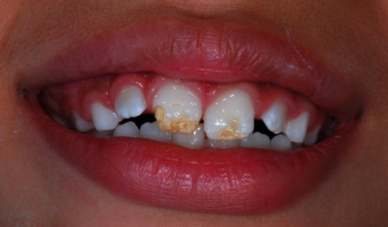
Solution
This issue may be helped by consuming food containing Vitamin D and Calcium, such as Vitamin D milk. If the individual finds this to be difficult given his dietary habits, he can supplement with Tums chewable tablets and multivitamins with Vitamin D (such as Flintstones Complete Children’s Multivitamin).
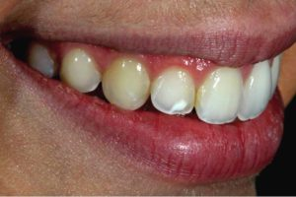
White fillings and sealants are two ways a dentist may treat the problem. However, because the enamel is already affected, it may continue to detach itself, leading to further decay and sensitivity. Later on, a silver crown may be needed in order to treat the condition accordingly.⁴

References

- Brankica Martinovic, Mirjana Ivanovic, Zoraida Milojkovic, Rasa Mladenovic, “Analysis of the Mineral Composition of Hypomineralized First Permanent Molars,” Vojnosanitetski Pregled (2015): 864-869
- N. Glodkowska, K. Emerich, “Molar Incisor Hypomineralization: Prevalence and Severity among Children from North Poland,” European Journal of Paediatric Dentistry (Vol. 20/1-2019): 59-66
- P. Norrisgaard, D. Haubek, J. Kunisch, “Association of High-Dose Vitamin D Supplementation During Pregnancy with the Risk of Enamel Defects in Offspring,” Jama Pediatrics (August 2019)
- Fiona Ng, Karen Kan, “Information About Molar Hypomineralization,” (October 2010)

https://www.ncbi.nlm.nih.gov/pubmed/26665551

